
SANDCASTLES POLICY

SAFEGUARDING & PROMOTING CHILDREN’S WELFARE

CHILD PROTECTION

FLOW CHART 1 REFERRAL
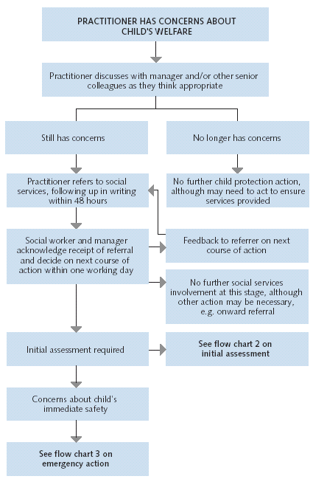

SANDCASTLES POLICY

SAFEGUARDING & PROMOTING CHILDREN’S WELFARE

CHILD PROTECTION

FLOW CHART 2 WHAT HAPPENS FOLLOWING INITIAL ASSESSMENT?
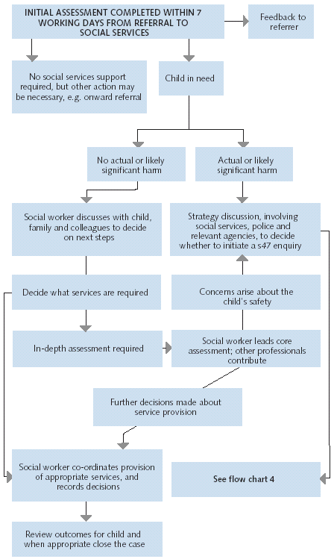
SANDCASTLES POLICY

SAFEGUARDING & PROMOTING CHILDREN’S WELFARE

CHILD PROTECTION

FLOW CHART 3 URGENT ACTION TO SAFEGUARD CHILDREN
